Applications I want you to get

* Visual studio express 2013 - [Download](http://www.visualstudio.com/downloads/download-visual-studio-vs#d-express-windows-desktop)
* SQL Server Express 2012 + SQL Management studio - [Download](http://www.microsoft.com/en-gb/download/details.aspx?id=29062)

Looks like :

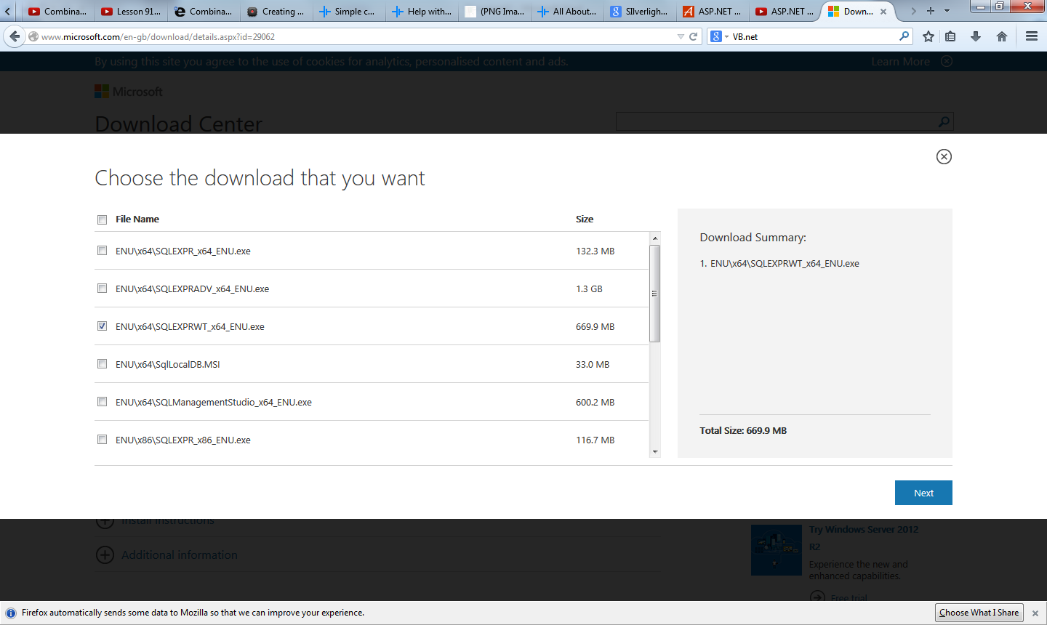

Depending on OS